**OS Assignments**

1. art by navigating to your home directory and list its contents. Then, move into a directory named "LinuxAssignment" if it exists; otherwise, create it.

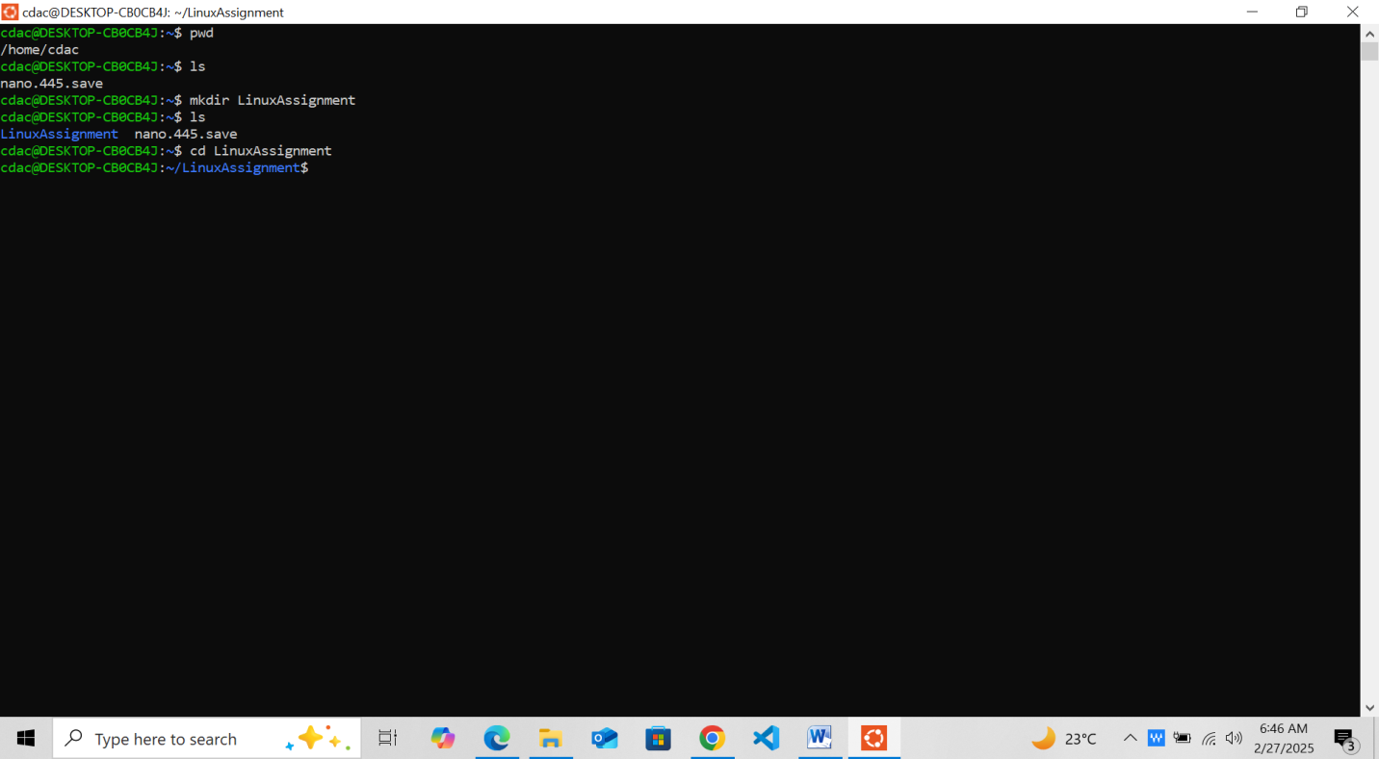

1. File Management: a. Inside the "LinuxAssignment" directory, create a new file named "file1.txt". Display its contents.

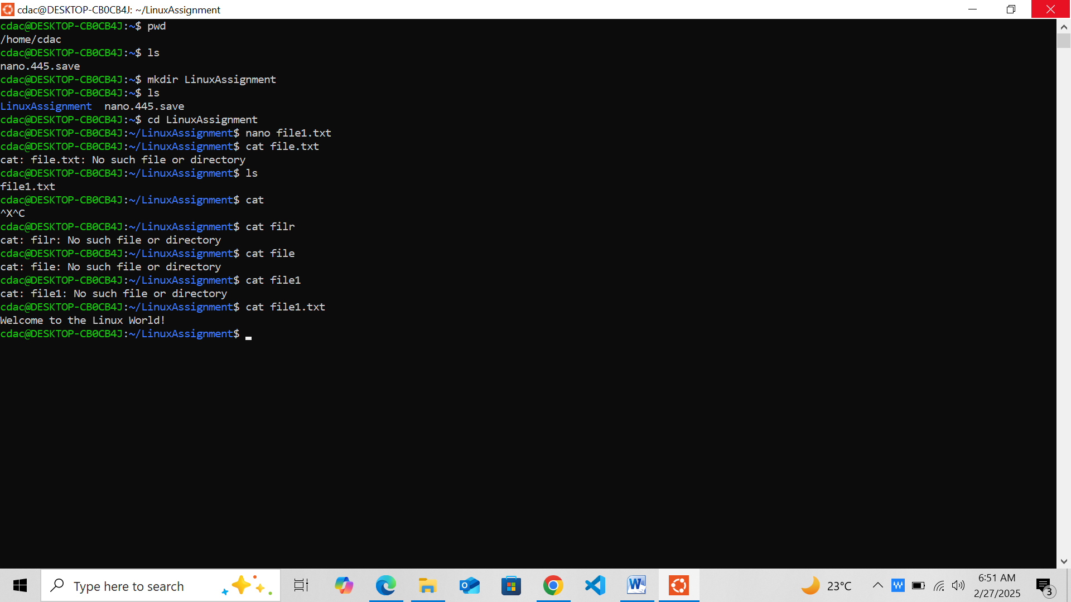

Answer:- While printing the file content without .txt I am getting error. But after putting .txt problem resolve and file content shows as output as **welcome to the Linux world**!

1. Directory Management: a. Create a new directory named "docs" inside the "LinuxAssignment" directory.



1. Copy and Move Files: a. Copy the "file1.txt" file into the "docs" directory and rename it to "file2.txt".

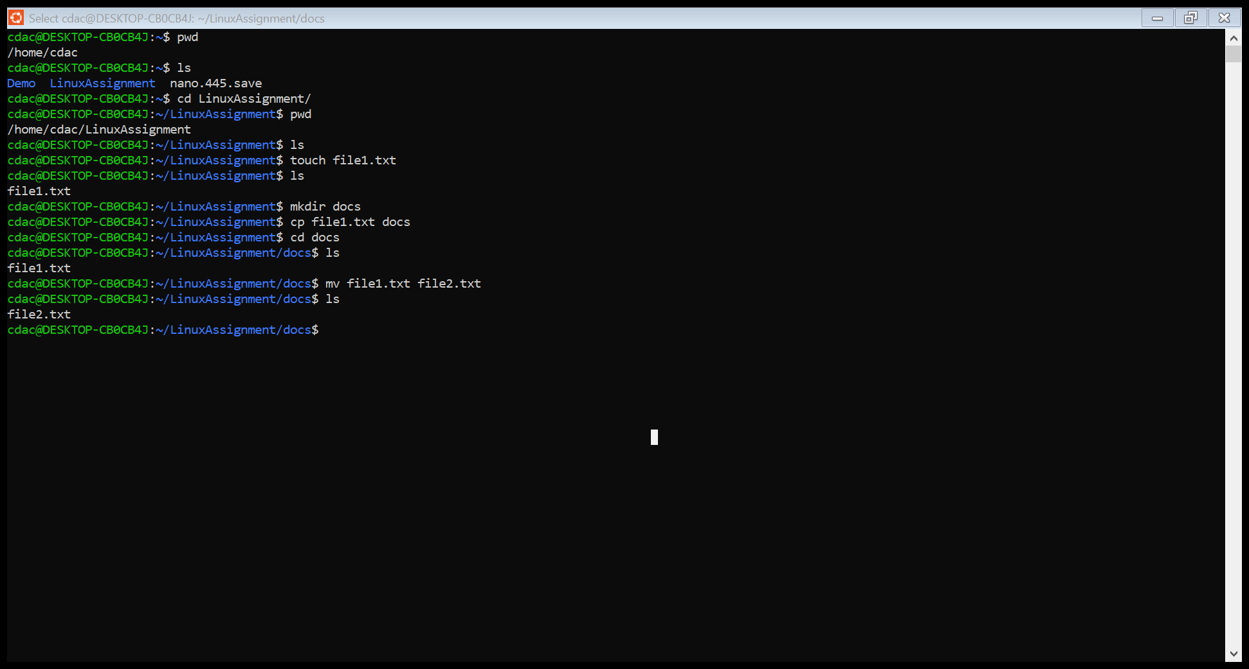

Answer:- (1**). cp command** is used to copy file from LinuxAssignment to docs.

(2). **Then mv command** is used to rename the file name.

1. Permissions and Ownership: a. Change the permissions of "file2.txt" to allow read, write, and execute permissions for the owner and only



**Answer:-** Using chmod 7 command change the permission of file2.txt to allow read,write, and execute permission for owner and read for others.

Then using chown command change the file2.txt owner with the current owner.

f) Final Checklist: a. Finally, list the contents of the "LinuxAssignment" directory and the root directory to ensure that all operations were performed correctly.

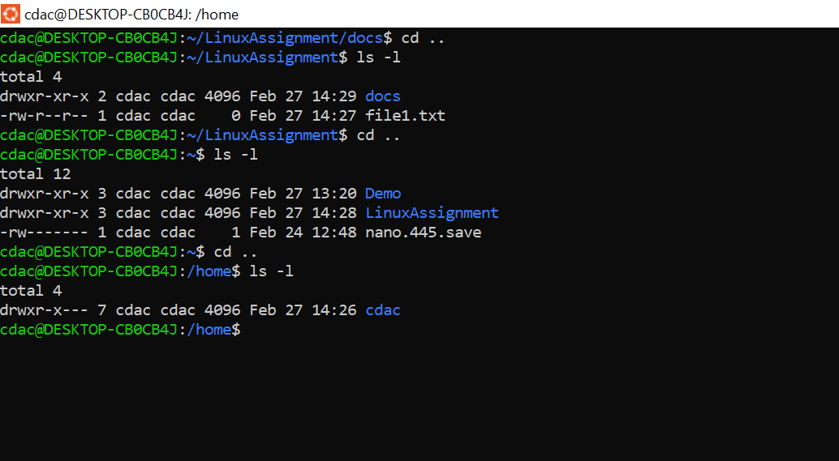

**Answer:-** I have used **ls –l** command to list al the contents of LinuxAssignment directory.

1. File Searching: a. Search for all files with the extension ".txt" in the current directory and its subdirectories

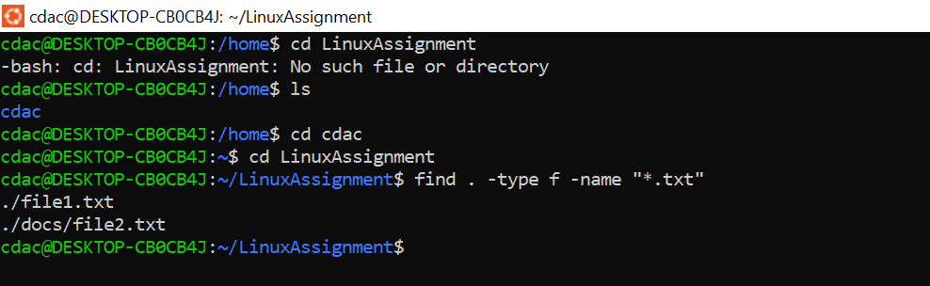

Answer:= find . –type f –name “*.txt”

**find** - is a command

**.** – is for directory

**-type** – is for file type document we want to search

**f** – find type of document we want search. -name “.txt” file name matching with .txt extension

. b. Display lines containing a specific word in a file (provide a file name and the specific word to search).

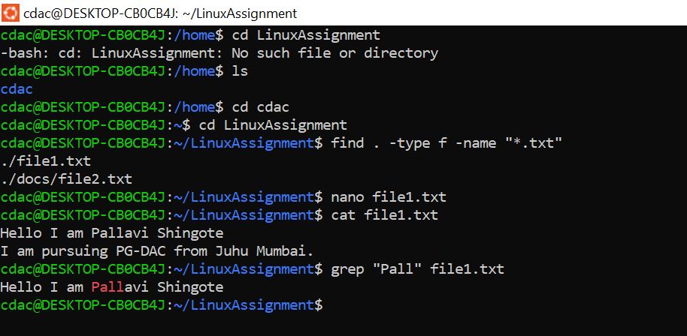

**grep** it is command used to check specific pattern.

“ ” is used to mention specific word.

filename.txt used to file name need to give.

1. System Information: a. Display the current system date and time.



**date** command is used to Display the current system date and time.

1. Networking: a. Display the IP address of the system

**Answer:** hostname -I and ip addr these command are used to peint Ip address on console

1. . b. Ping a remote server to check connectivity (provide a remote server address to ping).

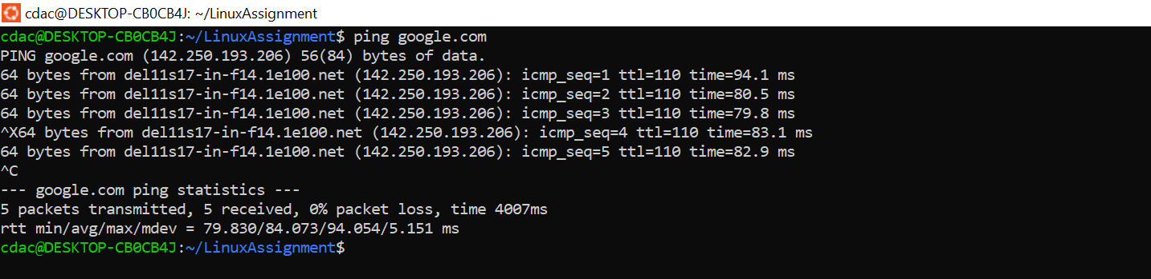

1. File Compression: a. Compress the "docs" directory into a zip file. b. Extract the contents of the zip file into a new directory.

k) File Editing: a. Open the "file1.txt" file in a text editor and add some text to it.



b. Replace a specific word in the "file1.txt" file with another word (provide the original word and the word to replace it with).

Old Output



New Output

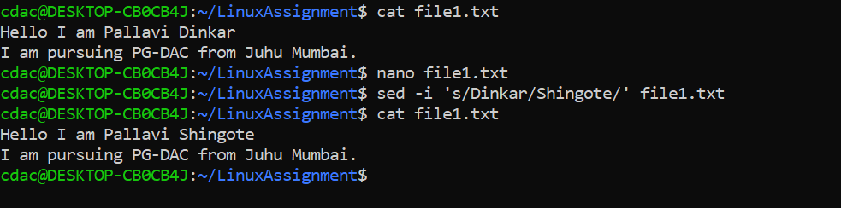

**Problem 2: Read the instructions carefully and answer accordingly. If there is any need to insert some data then do that as well.**

1. Suppose you have a file named "data.txt" containing important information. Display the first 10 lines of this file to quickly glance at its contents using a command.

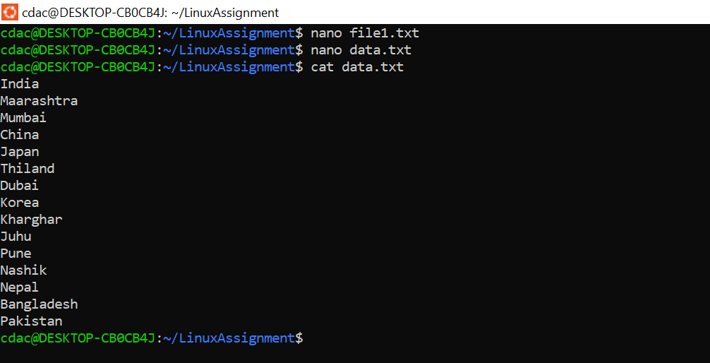

1. Now, to check the end of the file for any recent additions, display the last 5 lines of "data.txt" using another command.



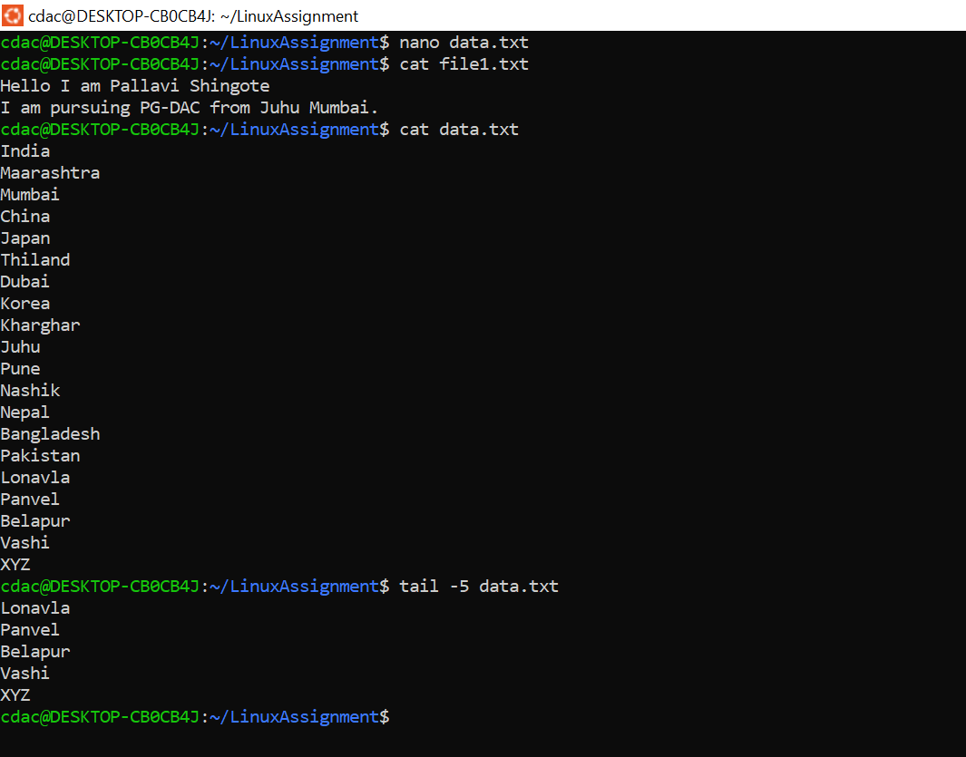

Using tail -5 data.txt last 5 lines of this file printed.

1. In a file named "numbers.txt," there are a series of numbers. Display the first 15 lines of this file to analyze the initial data set.

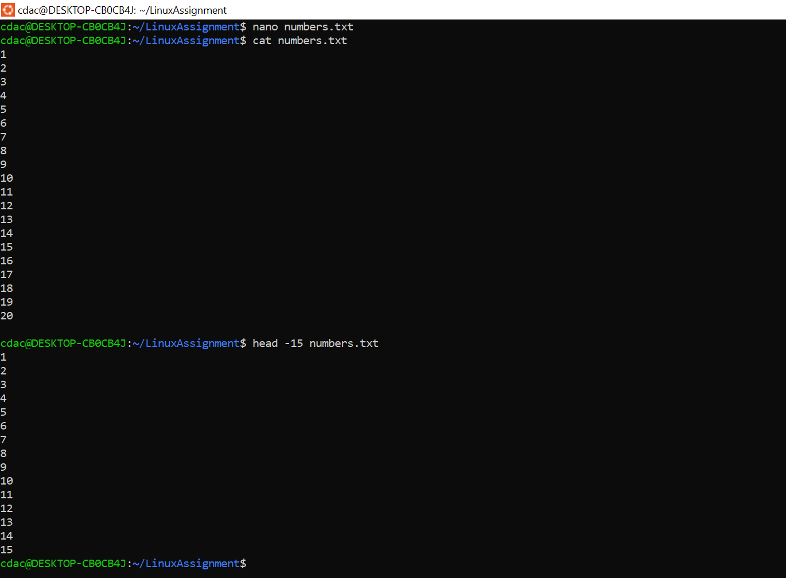

1. To focus on the last few numbers of the dataset, display the last 3 lines of "numbers.txt".

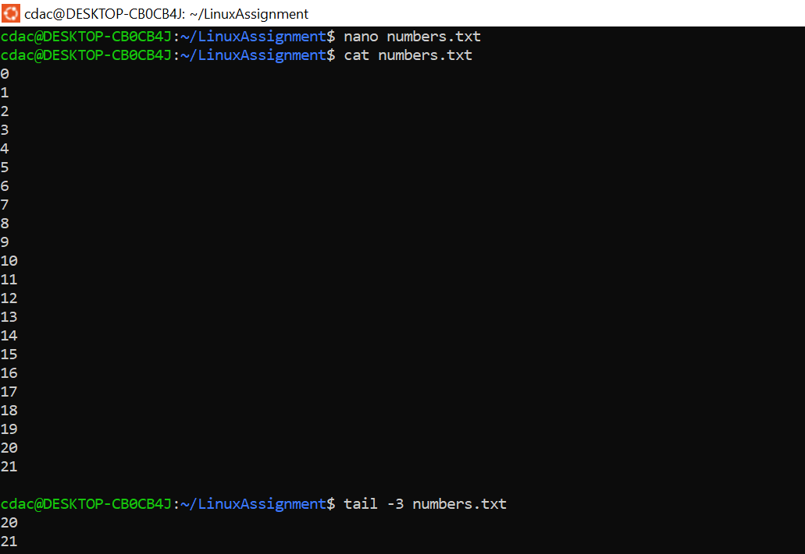

1. Imagine you have a file named "input.txt" with text content. Use a command to translate all lowercase letters to uppercase in "input.txt" and save the modified text in a new file named "output.txt."

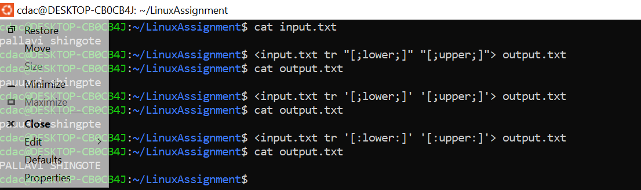

f.In a file named "duplicate.txt," there are several lines of text, some of which are duplicates. Use a command to display only the unique lines from "duplicate.txt."

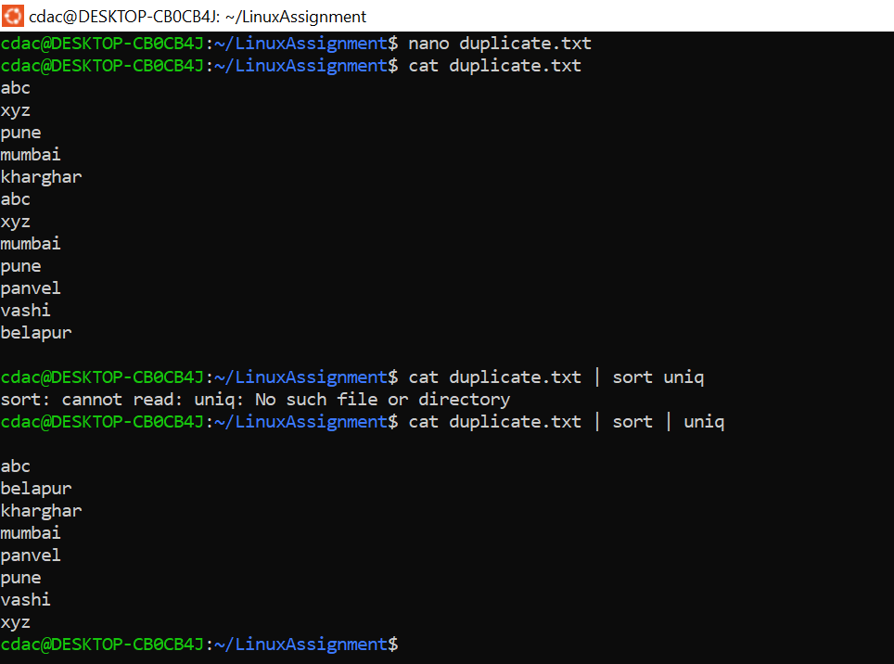

g. In a file named "fruit.txt," there is a list of fruits, but some fruits are repeated. Use a command to display each unique fruit along with the count of its occurrences in "fruit.txt."